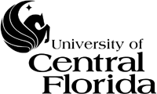

Florida High Tech Corridor Council
Phase II SBIR/STTR
External Investment Program

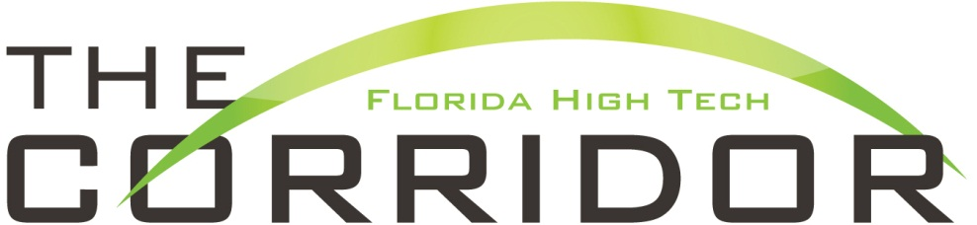
Office of the Vice President for Research & Commercialization

Due Date: No Deadline

Only Available to SBIR/STTR Phase I Award Winners

I. PROGRAM DESCRIPTION:
Proposals are sought for partnership projects between University of Central Florida (UCF) faculty and regional high technology industries along the Florida High Tech Corridor. The primary goal of the Florida High Tech Corridor Council (FHTCC) is to attract, grow, and retain high technology companies in the Florida High Tech Corridor area.
This program is specifically designed to increase opportunities for UCF students to gain valuable hands-on industrial research experience and to expand the research activities of an FHTCC industry partner by providing external investment funds to small companies to leverage research collaborations between Industry and UCF to assist in obtaining a Phase II SBIR/STTR award.
Approximately $2,000,000 has been designated for the two program areas of the Florida High Tech Corridor Council matching funds program for the current year. Award sizes will vary depending on the program and specific funding requests. An estimated $1.5M will be allocated to the open solicitation and an estimated $500K is allocated for the SBIR/STTR Phase II Industry External Investment program. The required ratio of industry match (cash and in-kind) is 1:3 (UCF : Industry Partner).
While projects may be proposed in any discipline, applications are particularly encouraged in areas contributing to the development of the high technology sectors encompassed within the Florida High Tech Corridor Initiative. The list below directly reflects the interest and goals of the Florida High Tech Corridor Council and the map illustrates the applicable Florida counties:

●Aerospace ●Nanotechnology
●Biotechnology ●Optic and Lasers
●Information Technologies and Services ●Renewable Energy
●Manufacturing Design ●Software Development
●Marine Technologies ●Simulation and Training
●Medical Products ●Solar Technology
●Medical Technologies ●Telecommunications
●Microelectronics ●Transportation Systems

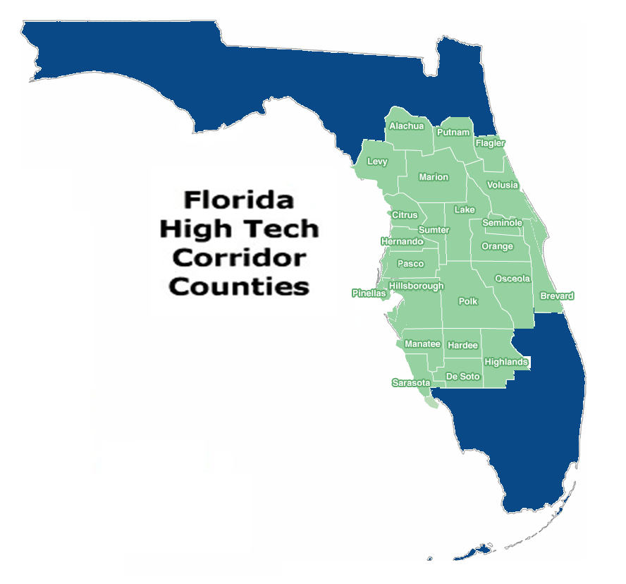

II. SBIR/STTR OVERVIEW:
(Excerpted from the Dartmouth Entrepreneurial Network Winter ‘03 Newsletter and DOD website.)

The Small Business Innovation Research (SBIR) is government funding targeted explicitly for commercialization by small businesses of research of any type. An STTR, or Small Business Technology Transfer program, is also government funding, but to be eligible a small business must team up with a Federal Lab or a University/College.

The government assigns funds to various agencies to use specifically for these purposes. Ten federal agencies are currently participating in these programs and to date approximately 60,000 SBIR grant awards have been made for a total of $10 billion.

There are three phases to each program: Phase I: Feasibility (up to $100K for 6 months), to help prove the basic concepts and build a business plan; Phase II: Main R&D Activity (up to $750K for an SBIR, or $500K for an STTR, for 24 months), to build and test prototypes, expanding on Phase I work; and Phase III: Commercialization. (Funding comes from private sources)

While these programs are geared to help promising ideas make their way to the commercial market, Phase II funding is not guaranteed; it is dependent on proven feasibility in Phase I.

There are two types of federal agencies to which you can apply. Contract agencies provide solicitations requesting submissions on ways to solve a specific need. For example the Department of Defense, as a contract agency, has funded ideas like highly mobile, simpler water purifying methods and for high performance thermal solutions for the cooling of electronic components and systems. If you win the SBIR/STTR funding, these agencies often become customers once the product reaches a commercial stage. Grant agencies support “good ideas.” The trick is to find out what they consider “good.” The National Institute of Health, for example, has granted SBIRs for prevention of alcoholism via computer software and for community voice mail for routine and disaster services. These agencies tend not to become customers; their primary goal is typically to improve society in some way.

You can apply to any number of agencies, but can accept only one award for an idea per Phase. These programs are excellent sources of grant funding that can get a venture off the ground. There is no application fee and the funding does not need to be repaid. But it does take a fair bit of research and work to gain approval.

Many small companies have found the Fast Track policy to be an effective tool for leveraging their SBIR (or STTR) funds to obtain additional funds from outside investors. This is because, under the Fast Track, a small company can offer an investor (University of Central Florida) the opportunity to obtain a match of between $1 and $4 in DoD SBIR (or STTR) funds for every $1 the investor puts in.

The investor funds may pay for additional R&D on the company's SBIR (or STTR) project or, alternatively, they may pay for other activities (e.g., marketing) that further the development and/or commercialization of the technology.

For example:

1. Potential Investment for a company that has never received phase II SBIR/STTR Funding: The company is required to find an investor that will provide funding at $0.25 for every $1 it requests from a federal agency.
Fast Track Program interim funding from Federal Agency $30-$50K

SBIR/STTR
Phase I company receives and nearly completes Phase I – invited to apply for Phase II
The company is eligible to apply for up to $150K from the FHTCC External Investment Program

SBIR/STTR Phase II company receives an award of up to $600K from the sponsor.

Result: Company receives $600K SBIR/STTR award plus FHTCC external investment funds valued at $150K for total research effort of $750K. In this example, the company provides UCF with a subcontract for $150K and the FHTCC provides the additional $150K investment in the university research effort, on behalf of the company.

2. Potential Investment for a company that has received Phase II SBIR/STTR Funding: A company is required to find an investor that will provide funding at $1 for every $1 it requests from a federal agency.

III. AWARD INFORMATION:

It is estimated that 5 awards will be issued. The maximum award size is $150K for direct costs only. No F&A is charged on the FHTCC portion.

The Phase II SBIR/STTR External Investment Program is only available to SBIR/STTR Phase I award winners. Investment funds from this program are available to SBIR/STTR Phase I winners to create partnerships with UCF faculty and provide the necessary external investment necessary to selected phase I winners to qualify for the Phase II SBIR/STTR Fast Track program. Information on the Fast Track program is available at: http://www.sba.gov/content/technology-sbirsttr

IV. PROPOSAL PREPARATION AND SUBMISSION INSTRUCTIONS:

A. Proposal Preparation Instructions
(Please read the entire guidelines before beginning the proposal preparation process)

- The SBIR/STTR phase I award winner must select a university partner to develop a research program that can continue the effort of the SBIR/STTR Phase I award. Please be advised that there is a required cash and in-kind match commitment from the industry partner to qualify for this matching support. The required ratio of industry match (cash and in-kind) is 1:3 (UCF : Industry Partner). Please review Section II.1 and Section III.B of this solicitation for examples and the specific guidance concerning funding requirements.

- Faculty and the industry partner operations staff are strongly encouraged to discuss their proposal with the respective legal/contracting offices prior to submitting the proposal to reduce the time from award to execution of the project.

- The University of Central Florida’s Office of Research & Commercialization will provide a letter of commitment, subcontract budget, and UCF Work Plan to the small business for their Phase II SBIR/STTR application.

B. Budgetary Information

  - Investment funding is available up to $150K in research for the program.

    - Proposals submitted under this solicitation require cash and in-kind funding from the FHTCC industry partner in order to qualify for FHTCC external investment funds. The required ratio of industry match (cash and in-kind) is 1:3 (UCF : Industry Partner). These funds are contingent upon receiving a Phase II SBIR/STTR award.

C. Deadline Dates

There is no application deadline for this solicitation. Proposals will be reviewed on a first come first serve basis each year and awards for exceptional and eligible proposals will be granted until funds are exhausted.

D. Proposal Application Format
(The budget can be accessed in MS Excel by clicking on the budget link below).

- UCF Proposal Transmittal Form:
  - Complete the on-line UCF Proposal Transmittal Form (PTF) electronically through “My Research” and then please notify your Proposal Manager. Please note that when completing the on-line entry, select College/Department under the “Sponsoring Organization,” scroll down to the Office of Research & Commercialization, then click the plus symbol (+), then click “UCF/I-4.”
OR
  - Complete the hard copy UCF Proposal Transmittal Form (PTF) electronically (please notify your Proposal Manager) with required signatures and cost share/matching as indicated. Please write “UCF/I-4” for the agency name.
- Cover Page: Complete cover page.
- Technical Description: Maximum of 5 pages, single spaced, 12-point type and one-inch margins on top, bottom, left and right. The technical description should only detail the UCF Work Plan. Include a three-sentence layman’s abstract that will be published if your project is awarded.
- References (Optional): You may include one additional page for references.
- Budget: Complete both columns for the FHTCC match request and the industry partner cash funds. Facilities & Administrative costs (formerly indirect cost) are not applicable to the FHTCC matching portion but must be included as a part of the industry partner portion unless an F&A Rate Reduction Request is granted (if applicable). Please download the current Fringe Benefit rates and F&A (formerly indirect costs) rate(s). Please include a list of the in-kind match from the FHTCC industry partner on the bottom of the budget for evaluation purposes.
- Industry Commitment: Include evidence of SBIR/STTR Phase II invitation to apply. In addition, a letter on company letterhead signed by an authorized representative of the company listing the project title and total UCF subcontract amount is required.
- Resume: Include a resume of no more than two pages for the PI or Project Director and any Co-Principal Investigators. You may use the provided format or your own format.
- Publications: Submit a copy of the title pages of the two most recent refereed publications dealing with the proposed research.
- Evaluation Sheet: Complete only the first three lines of the Evaluation Sheet.

V. MERIT REVIEW CRITERIA:

The Office of Research & Commercialization will review the FHTCC Phase II SBIR/STTR External Investment request, determine eligibility, and issue the appropriate commitment letter.

VI. AWARD ADMINISTRATION INFORMATION:

    - Each College, Department, Institute, and Center has an assigned Contract Manager or Contract Administrator. The Contract Manager or Contract Administrator assigned to your area can be located through the following website:
http://www.research.ucf.edu/Research/Administrators.html

    - The industry contracts should be executed within 4 months of award notice. Failure to do so could result in the cancellation or reallocation of matching funds to other projects. Additionally, if the industry partner reduces its award amount, then the FHTCC requested amount would also be reduced proportionately. For reporting purposes, a letter validating in-kind industry support will be requested at the end of the project.

Submission:

You are encouraged to submit your application on-line through “My Research” located on the ORC website. Please notify your Proposal Manager when submitting electronically. If you cannot submit on-line, then please provide a completed hard copy version to your assigned Proposal Manager in the Office of Research & Commercialization. The sponsoring agency on the Proposal Transmittal Form (PTF) should be addressed to:

Dr. Thomas O’Neal, Associate Vice President for Research
Office of Research & Commercialization
12201 Research Parkway, Suite 501
Orlando, FL 32826-3246
Office: 407-823-3778

Total Requested Funding: (Cash amounts only) Do not list in-kind on this section

FHTC Match Industry Partner Funding Total Effort

____________ + ______________________ = __________

Cover Page
Principal Investigator
Department
Co-Principal Investigator
Department
Co-Principal Investigator
Department
Chair
Dean
Title of Proposal
Industry Partner (company name, point of contract and address)
Phone
Fax
E-Mail

Total Requested Funding (Cash amounts only): Please do not list in-kind on this section.

FHTCC Request Industry Partner Funding Total Effort for Match

+ =

Current Academic Rank
6. Years at UCF

RESUME FOR PRINCIPAL INVESTIGATOR
1. ...
Name
2.
Department/College/
Center/Institute
3.
Phone
4.
Title of Proposal
5.
7.
Degrees Earned
Field
Institution
Year
For questions 8 and 9, use remainder of this page and no more than one additional page with PI's
name on header.
8.
Publications Summary (Please list 5 most relevant publications)

9.
Research and related experience
(Please summarize work experience and research experience, including employer, title, inclusive of appointment,
and external funding received at UCF or elsewhere as PI or Co-Pl, including consulting and patient activities.)

TOTAL
1
2
3
4
5
6
7
1
2
3
4
5
6
7
1
2
3
4
5
6
7
1
2
3
4
5
6
7
1
2
3
4
5
6
7

EVALUATION SHEET
1. Name
2. Department/College/
Center/Institute
3. Title of Proposal
Circle the application rating:
Weak
Acceptable
Strong
Excellent
I.
Technical Merit
II.
Meets FHTCC goals
III.
Specificity and
Credibility of
Funding Sources
IV.
Strength of
Partnership
V.
Student Involvement
Comments:

BUDGET

Click here for the Excel version of the budget

FINAL TECHNICAL REPORT

- Recipient name: University of Central Florida Award Amount: . .

- Principal Investigator: . .
- Co-Principal Investigator(s) (if applicable): . .

. .

- Agency’s Project Number: UCF Project Number: .

- Project Title: -
- Award Dates (including any granted no-cost extensions):

  - Start Date: End Date: -

- Brief description of project objectives:

- Were these objectives accomplished as scheduled?

- If objectives were not accomplished, please provide reason(s):

- Detail the most relevant activities of the project:

FINAL TECHNICAL REPORT (page 2 of 2)

- Describe project findings. Are these consistent with anticipated findings?

- Detail any publication(s) resulting from this project:

- Describe any other specific products and contributions of the project:

- List general conclusions (use additional pages as needed):

